GOVERNMENT ARTS COLLEGE FOR WOMEN
KRISHNAGIRI
Department of Computer Science | B.Sc. Computer Science

PROJECT TITLE
AI FAQ Assistant — AI-Powered FAQ and Customer Support Automation
Node.js • Express.js • MongoDB • Google Gemini AI
MVC Architecture • JWT Authentication
TEAM ID : SWTID-2026-9787
TEAM SIZE : 5
Submitted by
S.No | Team Member
1 | A. SAVITHA JENIFER
2 | K. SATHYA
3 | M. SOUNDARYA
4 | P. SOWMIYA
5 | M. SOWMIYA

Course / Department | B.Sc. Computer Science
Institution | Government Arts College for Women, Krishnagiri
Academic Year | 2024 – 2027

AI FAQ Assistant — AI-Powered FAQ and Customer Support Automation
Description:
- The AI FAQ Assistant backend is a secure, scalable, and AI-powered RESTful application developed to streamline FAQ creation, semantic search, and intelligent customer support automation. Built using Node.js, Express.js, MongoDB, and Mongoose, the backend exposes REST APIs that enable secure user authentication, complete FAQ management, keyword-based FAQ search, and AI-assisted content generation.
- The application follows the Model-View-Controller (MVC) architecture, making the project modular, maintainable, and scalable. User authentication is implemented using JSON Web Tokens (JWT), while passwords are securely encrypted using bcrypt before storage in MongoDB. Every protected API validates the JWT token through middleware before allowing access to sensitive resources.
- One of the key features of the project is its integration with Google Gemini AI, which automatically generates FAQ questions, answers, and topic suggestions from a short topic prompt. The AI module also assists support staff by generating instant answers to customer queries, reducing the time spent drafting repetitive responses.
- The backend returns standardized JSON responses, making it suitable for integration with web, mobile, and third-party support tools. Proper error handling, input validation, route protection, and modular service implementation ensure the application is reliable, secure, and easy to extend.
Scenario-Based Case Study:
Background
Priya is a customer support operations manager who handles a large backlog of repetitive user inquiries. Although her team resolves queries consistently, she finds it difficult to organize FAQ entries, classify topics, write precise answers, and track recurring question trends across categories.
Problem
- Difficulty generating and maintaining up-to-date FAQ documentation.
- Time-consuming manual process for drafting complete, accurate answers.
- No centralized, searchable record of previously answered questions.
- No secure way to restrict who can create, edit, or remove FAQ content.
- No AI assistance to speed up the drafting of new FAQ entries.
Solution
- The AI FAQ Assistant provides a centralized backend system where authorized staff can securely register, authenticate, and manage FAQ records. Users can create, update, delete, retrieve, and search FAQs through RESTful APIs. By integrating Google Gemini AI, the application generates ready-to-use FAQ questions and answers from a topic, and produces instant AI answers for incoming customer queries.
- The backend follows industry-standard security practices including JWT authentication, password hashing, middleware-based authorization, centralized error handling, and MongoDB schema validation.
Usage:
User Usage
A registered user can create an account using the registration endpoint and securely log in using email and password. After successful authentication, the backend generates a JWT token that authorizes access to protected APIs.
Using authenticated APIs, users can:
- Create new FAQ records.
- View all published FAQs.
- Retrieve a FAQ by its unique identifier.
- Update existing FAQ information.
- Delete unwanted FAQ records.
- Search FAQs using keywords or category.
- Generate AI-powered FAQ pairs from a topic.
- Request an instant AI-generated answer to a query.
AI Usage:
The AI module communicates with Google Gemini using a dedicated service layer.
Users provide information such as:
- Topic
- Customer Query
Gemini processes this information and returns:
- A generated FAQ question and answer pair
- A suggested category
- An instant answer to a customer query
- Clear, support-ready wording
Outcome:
- The AI FAQ Assistant significantly improves support operations by eliminating manual FAQ drafting and enabling fast, consistent knowledge-base growth. Secure authentication ensures that only authorized users can create or modify FAQ content, while AI assistance helps the team respond to customers faster and more accurately.
- The modular MVC architecture enables easy maintenance and future scalability. The application can later be extended with features such as FAQ analytics, multilingual answers, chatbot integration, and customer feedback ratings without major architectural changes.
1. Software Requirements
The AI FAQ Assistant requires the following software components for development and execution.
- Operating System: Windows 10/11, macOS, or Linux (supports cross-platform operations).

- Node.js (v18 or above): Runtime ecosystem running server logic and routing infrastructure.

- npm (v9 or above): Node package manager to control operational dependencies.

- Express.js: Lightweight routing web framework to construct backend RESTful entry points.

- MongoDB: Document NoSQL engine storing users, FAQs, and category data.

- Postman / Thunder Client: API verification toolkit to assert schema validation responses across protected routes.

- Code Editor: Visual Studio Code or a similar IDE environment.
2. Hardware Requirements
- Processor: Intel Core i5 (8th Gen or above) / AMD Ryzen 5 or equivalent.

- RAM: 8 GB minimum (16 GB recommended for concurrent instances of MongoDB, processing layers, and execution nodes).

- Storage: 1 GB of available disk workspace.

Epic 1: Project Architecture
Client
Postman / Thunder Client / Frontend App
↓
Express Server
app.js — CORS, JSON Parser, Route Registration
↓
Authentication Middleware
JWT Verification (authMiddleware.js)
↓
API Routes
authRoutes.js • faqRoutes.js • aiRoutes.js
↓
Controllers
authController.js • faqController.js • aiController.js
↓
Services & Mongoose Models
geminiService.js (Google Gemini AI) • User.js / FAQ.js
↓
MongoDB Database
Users Collection • FAQs Collection

- The AI FAQ Assistant follows a layered architecture based on the MVC (Model–View–Controller) design pattern. The application separates routing, business logic, database interaction, middleware, and AI services into independent modules, making the project easier to maintain and scale.
- When a client sends an HTTP request, the Express server receives it and forwards it to the corresponding route. Protected routes first pass through the authentication middleware, which validates the JWT token before granting access. Controllers process validated requests and invoke business logic or AI services as required. Database interactions are handled through Mongoose models, while Google Gemini AI is accessed through a dedicated service layer. Finally, the controller returns a structured JSON response to the client.
- This layered approach improves modularity, security, and maintainability while ensuring that each component has a single responsibility.
Overall Architecture Components:
- Client Application (Postman / Thunder Client / Frontend App)
- Express Server
- API Routes
- Authentication Middleware
- Controllers
- Services
- Google Gemini AI Service
- MongoDB Database
- Mongoose Models
Each component communicates through well-defined interfaces, ensuring loose coupling and easier future enhancements.
Components Definition:
The AI FAQ Assistant follows a modular backend architecture in which every component performs a dedicated responsibility. The separation of concerns ensures maintainability, scalability, and efficient execution of requests. Each request passes through multiple layers before reaching the database or AI service, ensuring secure and reliable processing.
1. Client Layer (Frontend / API Consumer)
The Client Layer is the entry point of the application. It can be a frontend application, mobile application, or API testing tool such as Postman / Thunder Client. The client sends HTTP requests to the backend server and receives JSON responses.
Responsibilities
- Sends API requests.
- Displays FAQ information.
- Stores JWT token after login.
- Invokes AI generation APIs.
- Displays success and error responses.
APIs Accessed
- Authentication APIs
- FAQ APIs
- AI Generation API
- AI Answer API
2. Express Server Gateway
The Express server acts as the central gateway of the application. It listens for incoming requests, configures middleware, parses request bodies, enables CORS, and routes requests to the appropriate controllers.
Responsibilities
- Starts the HTTP server.
- Parses JSON requests.
- Enables Cross-Origin Resource Sharing (CORS).
- Registers application routes.
- Connects middleware.
- Handles centralized errors.
3. Authentication Middleware
Authentication middleware protects all secured APIs by validating the JSON Web Token (JWT). Every protected request must include a valid Authorization header.
Responsibilities
- Read Authorization Header
- Extract JWT Token
- Verify JWT Signature
- Fetch User Record (excluding password)
- Attach User Information to Request
- Reject Unauthorized Requests
Benefits
- Prevents unauthorized access.
- Secures FAQ content.
- Allows only authenticated users to access protected APIs.
- Eliminates repeated authentication logic inside controllers.
4. Route Layer
Routes define the application's API endpoints and map incoming HTTP requests to controller methods. Each route represents a specific functionality of the system.
Authentication Routes
- Register User
- Login User
- Get User Profile
FAQ Routes
- Search FAQs
- Get All FAQs
- Get FAQ by ID
- Add FAQ
- Update FAQ
- Delete FAQ
AI Routes
- Generate AI Answer
- Generate AI FAQ
5. Controller Layer
Controllers contain the application's business logic. They receive requests from routes, validate input data, invoke services or database operations, and generate standardized JSON responses.
Authentication Controller — Responsible for:
- User Registration
- User Login
- User Profile Retrieval
FAQ Controller — Responsible for:
- Creating FAQ Records
- Retrieving FAQ Records
- Updating FAQs
- Deleting FAQs
- Searching FAQs
AI Controller — Responsible for:
- Sending prompts to Google Gemini.
- Receiving AI-generated content.
- Returning AI responses to clients.
6. Service Layer
The Service Layer contains reusable business logic that can be shared among multiple controllers.
Gemini AI Service — Responsible for:
- Preparing prompts.
- Sending prompts to Google Gemini.
- Receiving AI-generated responses.
- Returning formatted FAQ / answer content.
JWT Service — Responsible for:
- Creating JWT Tokens.
- Configuring Token Expiry.
- Verifying User Identity.
Password Service — Responsible for:
- Hashing Passwords.
- Comparing Passwords During Login.
7. Database Layer:
MongoDB stores all persistent application data. Mongoose acts as an Object Data Modeling (ODM) library that simplifies communication between Node.js and MongoDB.
Collections
- Users Collection
- FAQs Collection

Advantages:
- Flexible Schema

- High Performance

- Easy Data Retrieval

- Scalable Architecture

Entity Relationship (ER) Diagram Description:
The AI FAQ Assistant backend consists of collections that are logically connected through one-to-many relationships.
User
1 — N → FAQ | 1 — N → AI Generated FAQ
↓
Category
1 — N → FAQ (logical grouping)

1. User Entity:
The User entity stores authentication and profile information.
Attributes
Field | Type | Description
_id | ObjectId | Primary Key
name | String | User Name
email | String | Unique Email Address
password | String | Encrypted Password
role | String | Default: "user"
createdAt | Date | Record Creation Time
updatedAt | Date | Last Updated Time

Constraints:
- Email must be unique.
- Password is encrypted using bcrypt.
- Name is mandatory.
- JWT token is generated after successful login.
2. FAQ Entity
The FAQ entity stores each question-and-answer record created by an authenticated user.
Attributes
Field | Type | Description
_id | Object Id | Primary Key
question | String | FAQ Question
answer | String | FAQ Answer
category | String | Technology / Education / Health / Banking / General
Created By | Object Id | References User Collection
Created At | Date | Created Timestamp
Updated At | Date | Updated Timestamp

Constraints:
- Question is mandatory.
- Answer is mandatory.
- Category must match an allowed value (defaults to General).
- Every FAQ belongs to one authenticated creator.
3. AI Generation Entity (Logical):
Generated dynamically using Google Gemini AI before persistence.
- topic (String)
- generated Question (String)
- generated Answer (String)
- generated Category (String)
- generated At (Date)
4. Category Entity (Logical)
- category Name (String)
- description (String)
- total FAQs (Number)
Relationship:
User → FAQ

Relationship Type: One-to-Many
A single user can create multiple FAQ records. Each FAQ belongs to only one authenticated creator.
Example:
Savitha jenifer
- How do I reset my password?
- How do I configure custom category tags?
- What payment methods are supported?
This relationship is maintained using the created By field inside the FAQ schema, which stores the object id of the corresponding user.
Category → FAQ:
Each category can contain multiple FAQ documents.
User → AI Generated FAQ:
A user can generate multiple AI-assisted FAQs, which may later be saved into the FAQ collection.
FAQ → Search Results:
Search queries retrieve matching FAQ documents using keyword matching against the question, answer, and category fields.

Key Features
The AI FAQ Assistant provides a complete backend solution for FAQ management and AI-assisted customer support.
1. Secure Authentication
The application implements JWT-based authentication.
- User Registration
- Secure Login
- Password Encryption
- JWT Generation
- Protected APIs
2. FAQ Management
Users can perform complete CRUD operations.
- Add FAQ
- View FAQ
- Update FAQ
- Delete FAQ
3. FAQ Search
Users can search FAQs using:
- Keyword
- Category
4. Google Gemini Integration — FAQ Generation
The backend communicates with Google Gemini AI to automatically generate FAQ content from a topic.
- Input: Topic
- Output: Question, Answer, and Suggested Category
5. Google Gemini Integration — AI Answers
The AI module analyzes a customer query and returns an instant answer.
- Input: Customer Query
- Output: AI-generated Answer
6. Category Management
FAQs are organized into structured categories for easier navigation.
- Technology
- Education
- Health
- Banking
- General
7. Centralized Error Handling
The application returns meaningful JSON error responses for:
- Invalid Credentials
- Missing Authentication Token
- Duplicate Field Values
- Validation Errors
- Internal Server Errors
8. RESTful API Design
The backend follows REST principles.
- GET
- POST
- PUT
- DELETE
9. Modular Architecture
The project separates responsibilities into:
- Models
- Controllers
- Routes
- Middleware
- Services
- Configuration

Roles and Responsibilities
The AI FAQ Assistant supports four roles.
Admin
- Manage all registered users.
- View, update, and delete any FAQ.
- Monitor AI-generated content.
- Manage FAQ categories.
- Access complete system functionality.
Content Creator
- Create new FAQs.
- Edit personal FAQ records.
- Delete owned FAQs.
- Generate FAQs using AI.
- Organize FAQs under categories.
Authenticated User
- View public FAQs.
- Search FAQs using keywords.
- Generate AI-assisted answers.
- Access personal profile information.
Public User
- View published FAQs.
- Search FAQs.
- Cannot create, edit, or delete FAQ records.
- No access to protected API endpoints.

Permissions
Operation | Admin | Content Creator | Authenticated User | Public User
Register / Login | Yes | Yes | Yes | —
View FAQs | Yes | Yes | Yes | Yes
Search FAQs | Yes | Yes | Yes | Yes
Create FAQ | Yes | Yes | No | No
Update FAQ | Yes | Own Only | No | No
Delete FAQ | Yes | Own Only | No | No
AI FAQ Generation | Yes | Yes | No | No
AI Answer Generation | Yes | Yes | Yes | No

User Flow
Register / Login
Email + Password
↓
Receive JWT Token
Stored by client for future requests
↓
Access Protected Routes
Token sent as Bearer header
↓
Manage FAQs
Add / View / Update / Delete / Search
↓
Request AI Assistance
FAQ Generation • Instant Answers
↓
Receive JSON Response
Displayed to the user

MVC Architecture Pattern
The AI FAQ Assistant is designed using the Model–View–Controller (MVC) architecture pattern. This architecture separates application logic into independent components, improving code organization, maintainability, and scalability.
View
API Consumer — Postman / Thunder Client / Frontend App
↓
Controller
Business Logic — Validates input, calls Services & Models
↓
Model
Mongoose Schemas — User.js & FAQ.js → MongoDB

Model Layer (Data Layer)
The Model Layer defines the structure of the application's data using Mongoose schemas. It communicates directly with MongoDB and performs database operations. Models in the project include the User Model and the FAQ Model.
Responsibilities
- Schema Definition
- Data Validation
- CRUD Operations
- Collection Mapping
View Layer (API Interface)
Since the AI FAQ Assistant is a backend REST API, there are no traditional UI templates. The View Layer is represented by API consumers such as a frontend application, mobile application, or Postman / Thunder Client, which interact with the backend through HTTP requests and receive JSON responses.
Responsibilities
- Send Requests
- Receive JSON Responses
- Display Data
- Handle Client-side Interaction
Controller Layer (Business Logic)
The Controller Layer acts as the intermediary between the View and Model. It processes incoming requests, validates input, invokes services and models, and sends structured JSON responses back to the client.
Responsibilities
- Request Validation
- Business Logic Execution
- Database Interaction
- AI Service Invocation
- Response Generation
The separation of these three layers ensures loose coupling, simplifies testing, enhances code readability, and makes the application easier to extend with future features.

Epic 2: Project Setup and Configuration
The AI FAQ Assistant project follows a well-structured backend architecture that separates business logic, routing, database operations, middleware, and AI services into individual modules. This modular design improves code readability, maintainability, and scalability while making the project easier to debug and extend.
The backend is developed using Node.js and Express.js, with MongoDB as the primary database and Google Gemini AI for intelligent FAQ generation and query answering.
Creating Project Folder
Step 1: Create the Project Folder
Create a new folder with the project name:
AI-FAQ-Assistant-API
Step 2: Open the Project
Open the project folder in Visual Studio Code.
Step 3: Create the Server Folder
Inside the project directory, create a folder named:
src
All backend source code is maintained inside this folder.
Step 4: Initialize Node Project
Open the terminal inside the project folder and execute:
npm init -y
This command generates the package.json file containing project metadata and dependency information.
Step 5: Install Required Packages
Install the required dependencies:
npm install express mongoose dotenv cors jsonwebtoken bcrypt @google/genai
Install Nodemon as a development dependency:
npm install --save-dev nodemon
Project Folder Structure
src/
config/db.js
controllers/aiController.js
controllers/authController.js
controllers/faqController.js
middleware/authMiddleware.js
middleware/errorMiddleware.js
middleware/validationMiddleware.js
models/FAQ.js
models/User.js
routes/aiRoutes.js
routes/authRoutes.js
routes/faqRoutes.js
services/geminiService.js
utils/helpers.js
app.js
server.js
.env
Environment Variables
Sensitive information is stored in the .env file.
Example:
PORT=5000
MONGO_URI=mongodb://localhost:27017/aifaqassistant
JWT_SECRET=your_secret_key
GEMINI_API_KEY=your_google_gemini_api_key
Using environment variables improves security by preventing sensitive information from being exposed in source code.
Epic 3: Backend Development
- Backend development focuses on implementing REST APIs that allow authenticated users to manage FAQs and interact with Google Gemini AI.
- The project is divided into multiple modules that collectively perform authentication, FAQ management, AI integration, and database operations. Major modules include:
- Server Configuration
- Database Configuration
- Authentication
- FAQ Management
- AI Generation
- Middleware
- Error Handling
Core System Script Implementations
1. Gateway Server (src/server.js)
This entry-point script connects to the database and binds the network listener to the active environment port:
const app = require('./app');
const connectDB = async () => {
try {
const dbConnect = require('./config/db');
await dbConnect();
} catch (error) {
console.error('Failed to connect to the database', error);
}
};

const startServer = async () => {
await connectDB();
const PORT = process.env.PORT || 5000;
const server = app.listen(PORT, () => {
console.log(`Server running in ${process.env.NODE_ENV || 'development'} mode on port ${PORT}`);
});

process.on('unhandledRejection', (err, promise) => {
console.error(`Unhandled Rejection: ${err.message}`);
server.close(() => process.exit(1));
});
};

startServer();
2. Express App Setup (src/app.js)
Configures middleware, registers API routes, and wires the centralized error handler:
const express = require('express');
const cors = require('cors');
const dotenv = require('dotenv');
const { errorHandler } = require('./middleware/errorMiddleware');

dotenv.config();
const app = express();

app.use(cors());
app.use(express.json());
app.use(express.urlencoded({ extended: false }));

app.get('/', (req, res) => {
res.json({ success: true, message: 'AI FAQ Assistant API is running.', version: '1.0.0' });
});

app.use('/api/auth', require('./routes/authRoutes'));
app.use('/api/faqs', require('./routes/faqRoutes'));
app.use('/api/ai', require('./routes/aiRoutes'));

app.use(errorHandler);
module.exports = app;
3. Authentication Middleware (src/middleware/authMiddleware.js)
Extracts the Bearer token from the request header and verifies the user's identity before allowing access:
const jwt = require('jsonwebtoken');
const User = require('../models/User');

const protect = async (req, res, next) => {
let token;
if (req.headers.authorization && req.headers.authorization.startsWith('Bearer')) {
try {
token = req.headers.authorization.split(' ')[1];
const decoded = jwt.verify(token, process.env.JWT_SECRET);
req.user = await User.findById(decoded.id).select('-password');
if (!req.user) {
return res.status(401).json({ success: false, message: 'Not authorized, user not found' });
}
next();
} catch (error) {
return res.status(401).json({ success: false, message: 'Not authorized, token failed' });
}
}
};
module.exports = { protect };
4. Centralized Error Handler (src/middleware/errorMiddleware.js)
Converts Mongoose and Gemini SDK errors into consistent JSON error responses:
const errorHandler = (err, req, res, next) => {
let statusCode = res.statusCode === 200 ? 500 : res.statusCode;
let message = err.message;

if (err.status) statusCode = err.status;

if (err.code === 11000) {
statusCode = 400;
const field = Object.keys(err.keyValue)[0];
message = `Duplicate field value entered: ${field}. Please use another value.`;
}

if (err.name === 'ValidationError') {
statusCode = 400;
message = Object.values(err.errors).map((val) => val.message).join(', ');
}

if (err.name === 'CastError') {
statusCode = 404;
message = `Resource not found with id of ${err.value}`;
}

res.status(statusCode).json({ success: false, message });
};
module.exports = { errorHandler };

Epic 4: Database Configuration
The AI FAQ Assistant uses MongoDB as its primary NoSQL database for storing user credentials and FAQ records. Mongoose serves as the Object Data Modeling (ODM) library, enabling seamless interaction between the application and the MongoDB database. Mongoose provides schema validation, middleware support, data relationships, and simplified CRUD operations.
The database layer is responsible for maintaining data integrity, validating incoming requests, and ensuring secure storage of user and FAQ information.
MongoDB Configuration
MongoDB stores application data in collections rather than traditional relational database tables. The AI FAQ Assistant maintains separate collections for users and FAQs.
Database Collections
- Users Collection
- FAQs Collection
Each collection stores JSON-like documents (BSON format), allowing flexible schema design while maintaining efficient data retrieval.
Installing Mongoose
npm install mongoose
Mongoose acts as the bridge between the Node.js application and MongoDB by providing schema definitions, validation, and database methods.
MongoDB Connection
The database connection is configured inside the config/db.js file. This module establishes a connection to the MongoDB server when the application starts.
const mongoose = require('mongoose');

const connectDB = async () => {
try {
const conn = await mongoose.connect(process.env.MONGO_URI);
console.log(`MongoDB Connected: ${conn.connection.host}`);
} catch (error) {
console.error(`Error: ${error.message}`);
process.exit(1);
}
};

module.exports = connectDB;
Responsibilities
- Connect to MongoDB
- Handle Connection Errors
- Display Connection Status
- Export Database Connection
Advantages
- Centralized database configuration
- Reusable connection module
- Automatic connection management
- Simplified error handling
Mongoose Schemas
The AI FAQ Assistant backend contains two primary Mongoose schemas:
1. User Schema
2. FAQ Schema
Schemas define the structure, validation rules, and relationships for MongoDB documents.
1. User Schema (models/User.js)
The User schema stores authentication information for registered users and hashes the password automatically before saving.
const mongoose = require('mongoose');
const bcrypt = require('bcrypt');

const userSchema = new mongoose.Schema(
{
name: { type: String, required: [true, 'Name is required'], trim: true },
email: {
type: String,
required: [true, 'Email is required'],
unique: true,
lowercase: true,
trim: true,
match: [/^\S+@\S+\.\S+$/, 'Please provide a valid email address'],
},
password: {
type: String,
required: [true, 'Password is required'],
minlength: [6, 'Password must be at least 6 characters long'],
},
role: { type: String, default: 'user' },
},
{ timestamps: true }
);

userSchema.pre('save', async function () {
if (!this.isModified('password')) return;
const salt = await bcrypt.genSalt(10);
this.password = await bcrypt.hash(this.password, salt);
});

module.exports = mongoose.model('User', userSchema);
Validation Rules
- Name cannot be empty.
- Email must be a valid, unique address.
- Password must be at least 6 characters.
- Password is encrypted using bcrypt before saving.
- Automatic timestamps are enabled.
User Schema Features
- Email uniqueness validation
- Password hashing
- Automatic timestamps
- Role-based access support
- JWT integration
2. FAQ Schema (models/FAQ.js)
The FAQ schema stores each question-and-answer record and links it back to its creator.
const mongoose = require('mongoose');

const faqSchema = new mongoose.Schema(
{
question: { type: String, required: [true, 'Question is required'], trim: true },
answer: { type: String, required: [true, 'Answer is required'], trim: true },
category: {
type: String,
required: [true, 'Category is required'],
enum: {
values: ['Technology', 'Education', 'Health', 'Banking', 'General'],
message: '{VALUE} is not a valid category.',
},
default: 'General',
},
createdBy: {
type: mongoose.Schema.Types.ObjectId,
ref: 'User',
required: [true, 'Creator user reference is required'],
},
},
{ timestamps: true }
);

module.exports = mongoose.model('FAQ', faqSchema);
Validation Rules
- Question is mandatory.
- Answer is mandatory.
- Category must be one of the allowed enum values.
- Every FAQ belongs to one authenticated user.
- Automatic timestamps are enabled.
FAQ Schema Features
- Schema validation
- Category enum restriction
- Automatic timestamps
- Creator relationship
- Efficient CRUD operation
Epic 5: Project Execution
- Install Postman or Thunder Client (VS Code extension).
Start the backend development server:
npm run dev
API Testing
API testing ensures that every endpoint functions correctly and returns the expected response. The AI FAQ Assistant is tested using Postman / Thunder Client, allowing developers to verify request handling, authentication, database operations, and AI integration.
Testing is performed in the following order:
- Authentication APIs
- FAQ APIs
- AI APIs
Authentication API Testing
Register User
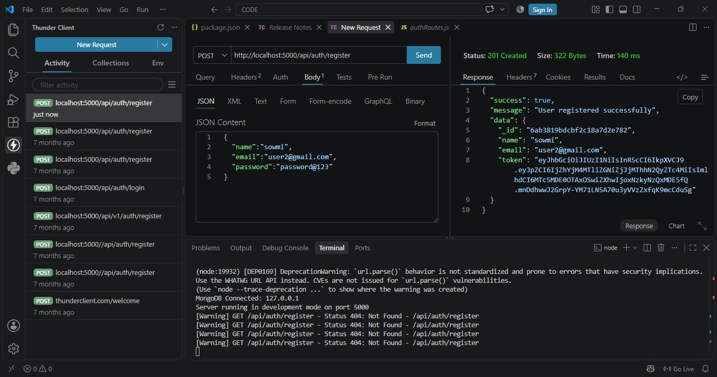

Login User
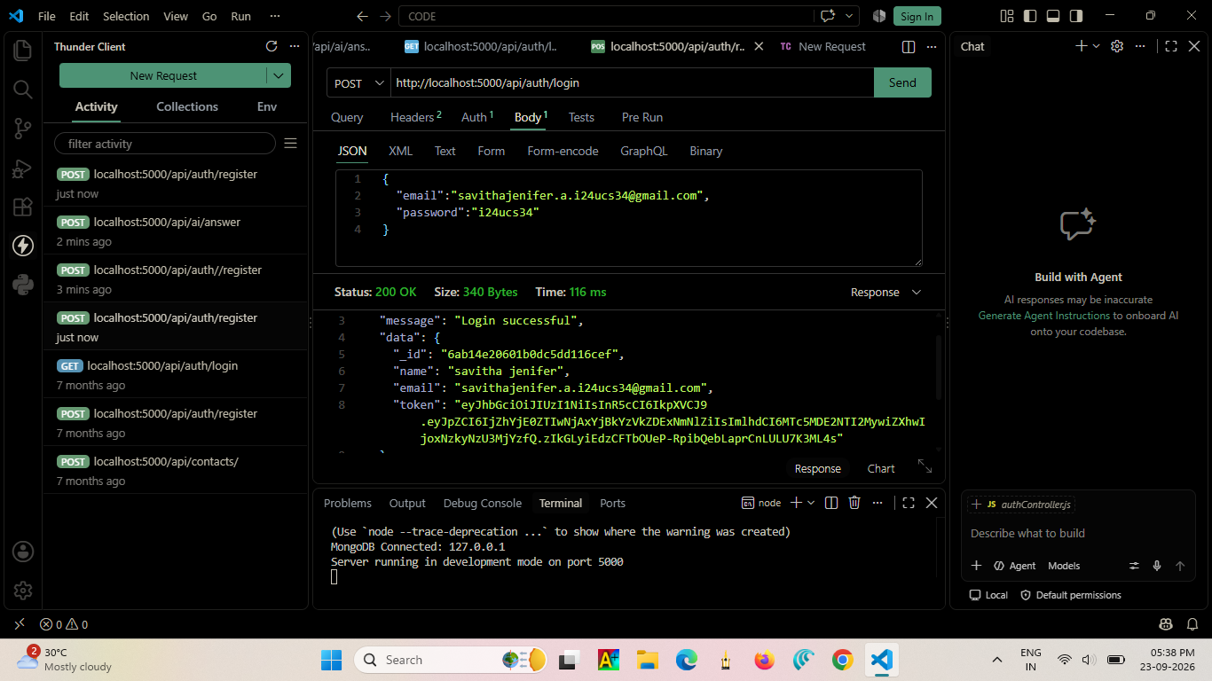

Get Profile
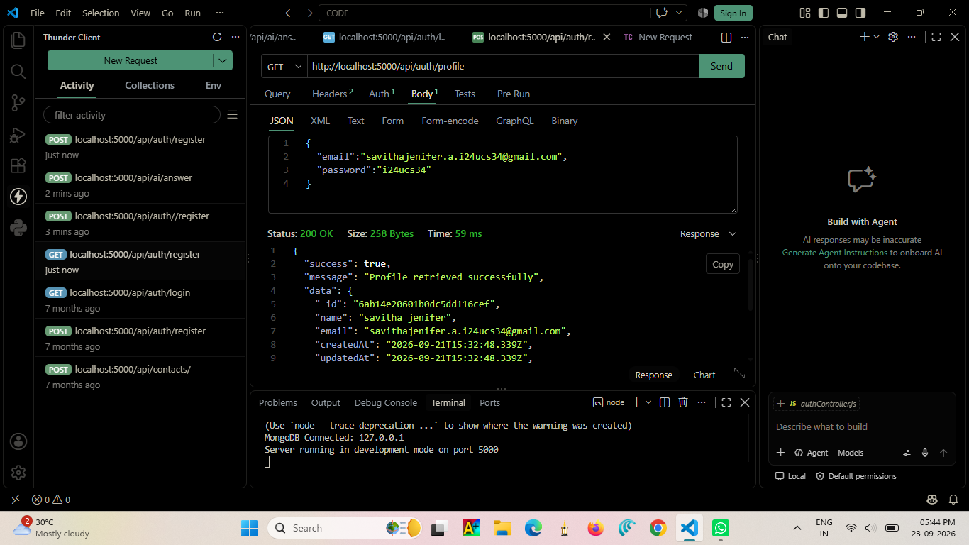

FAQ API Testing
Add FAQ
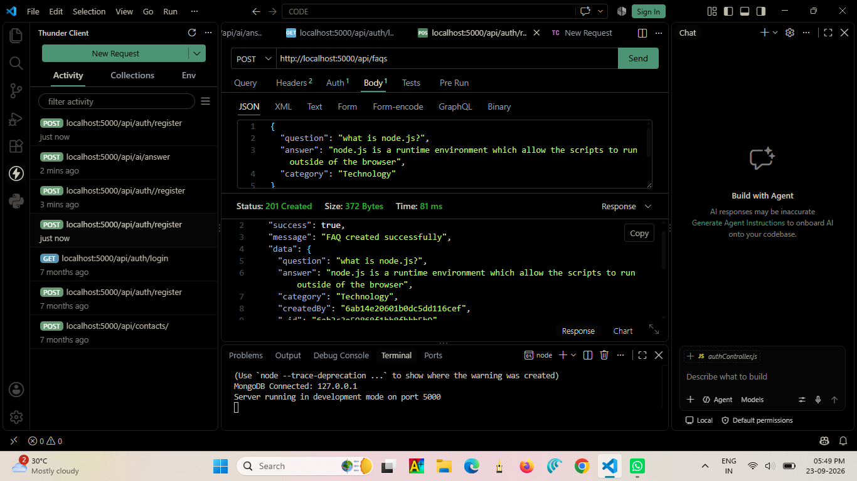
Get All FAQs
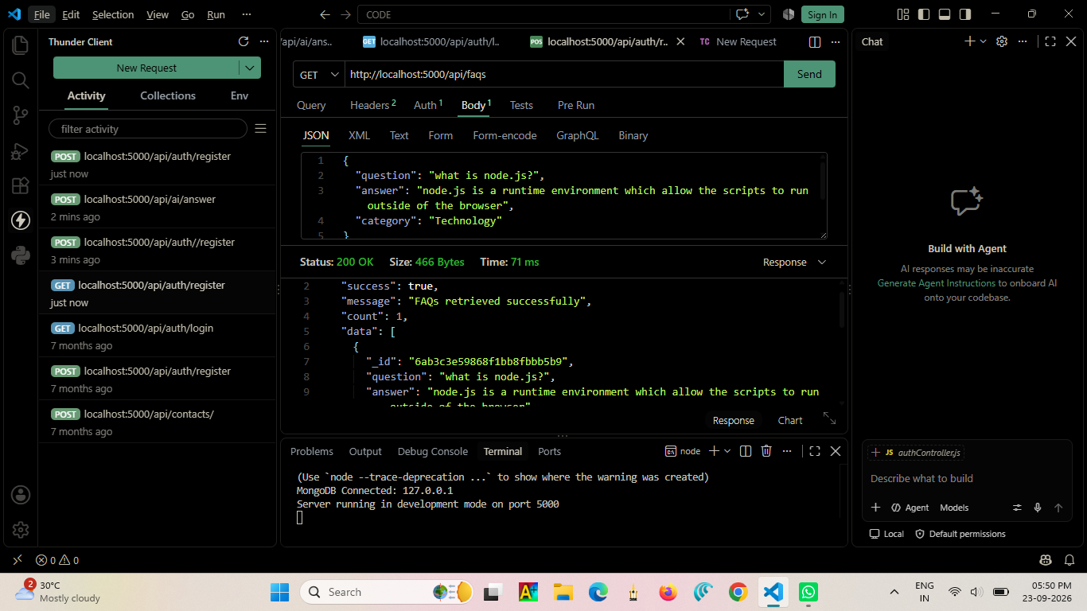

Get FAQ By ID
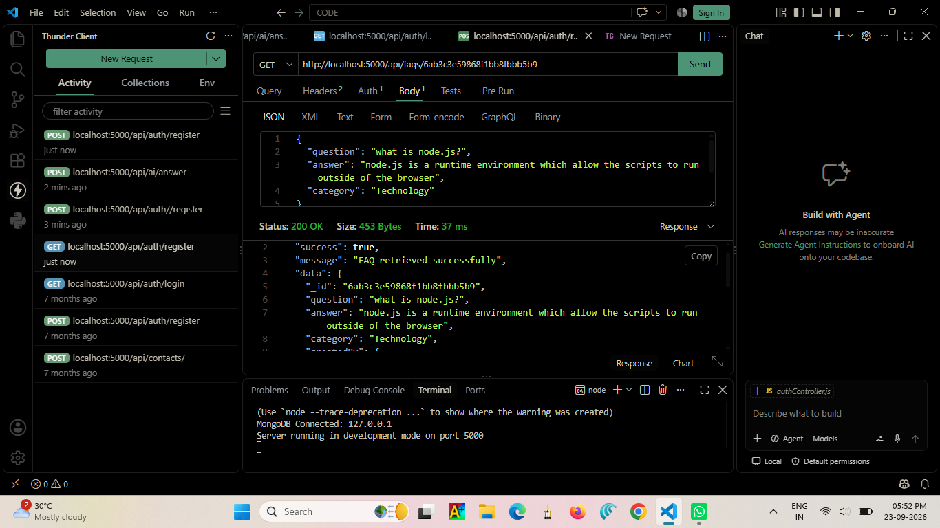

Update FAQ
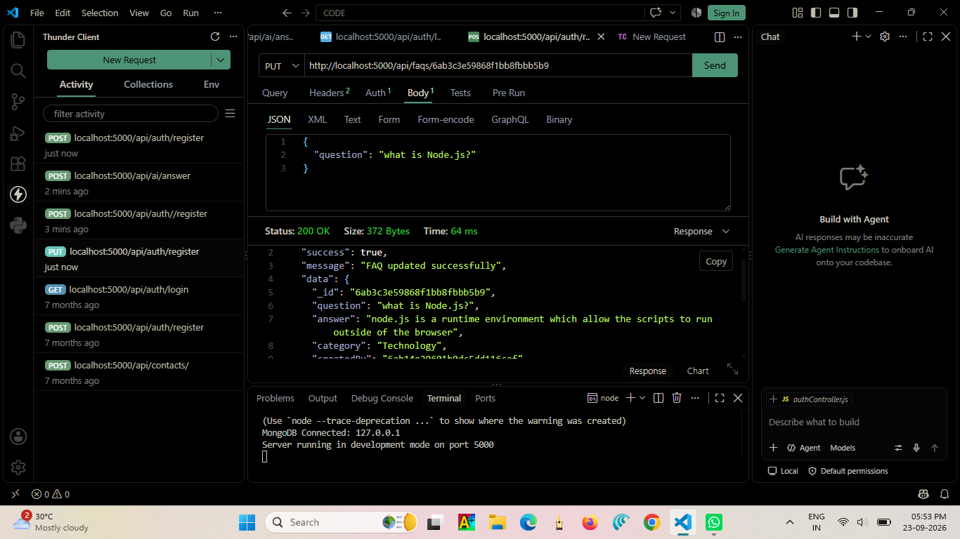

Delete FAQ
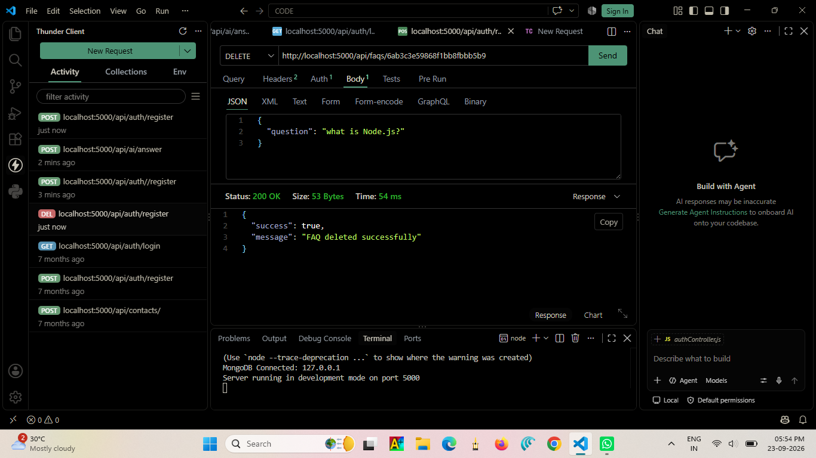

Search FAQs
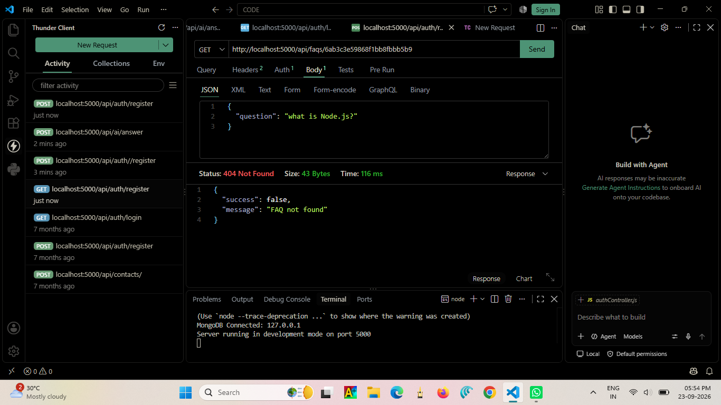

AI API Testing
Generate AI Answer
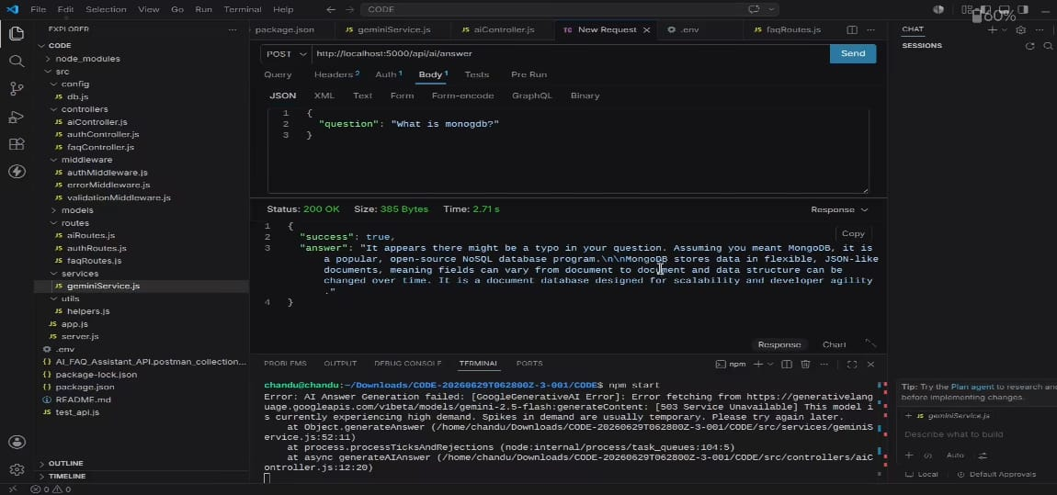

Generate AI FAQ
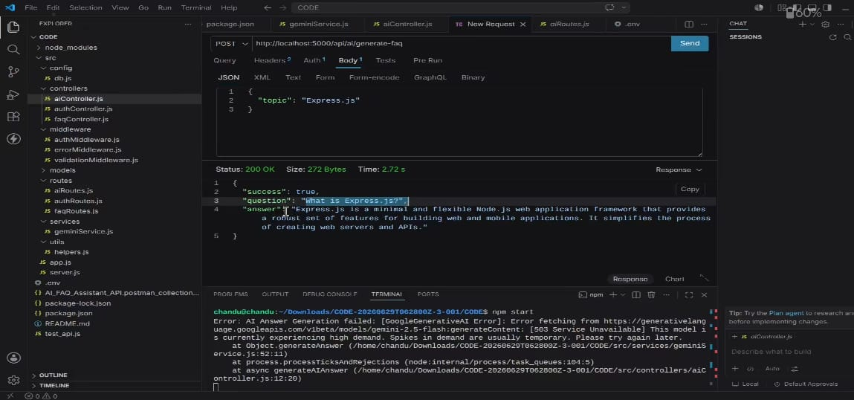

Project Links
Resource | Link
Demo Video Link | https://drive.google.com/file/d/1fepsMFah2hnIZt3Ix6W6_SpdgLyBirxG/view?usp=sharing

Conclusion:

- The AI FAQ Assistant – AI-Powered FAQ and Customer Support Automation provides an efficient and intelligent solution for handling frequently asked customer questions. By using Artificial Intelligence and Natural Language Processing (NLP), the system can understand user queries and provide quick, relevant, and automated responses.

- This system helps reduce the workload of customer support teams, saves time, improves response speed, and provides 24/7 customer assistance. It can also reduce repetitive manual work and improve the overall customer experience.

- Overall, the AI FAQ Assistant demonstrates how AI technology can be effectively used to automate customer support and provide faster, smarter, and more reliable FAQ services. In the future, the system can be enhanced with voice support, multilingual capabilities, advanced machine learning, chatbot integration, and continuous learning from user interactions.

